ASSIGNMENT ON SQL:-

1) Create A Table with Four Columns of Your Choice, Making That They Have Null Constraints

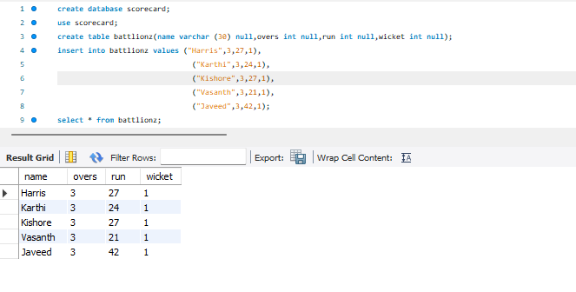

2) Create A Sales Table Having Columns ID, Product name, Price Per Unit and Quantity, and Then Create a View Which Will Show The Total Cost Per Each Product And Product Name

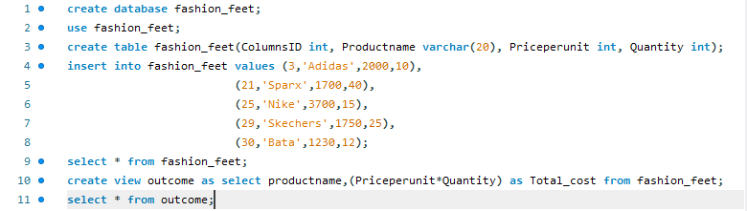



3. Your task for this challenge is to return a sum of all the ages in table

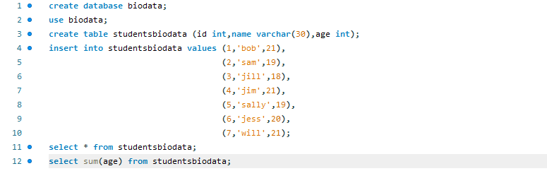



4. The challenge is to write a query that group all the people by their age, along with a count of the people that are the same age.

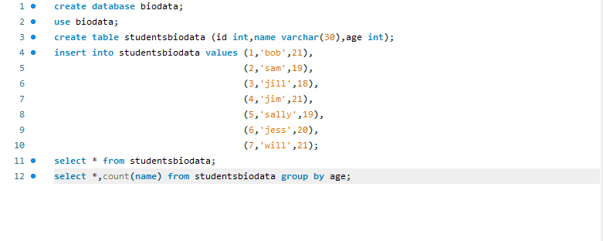



5. Write a query for this table that return just the division ids for all the divisions that had positive revenue in 2021

